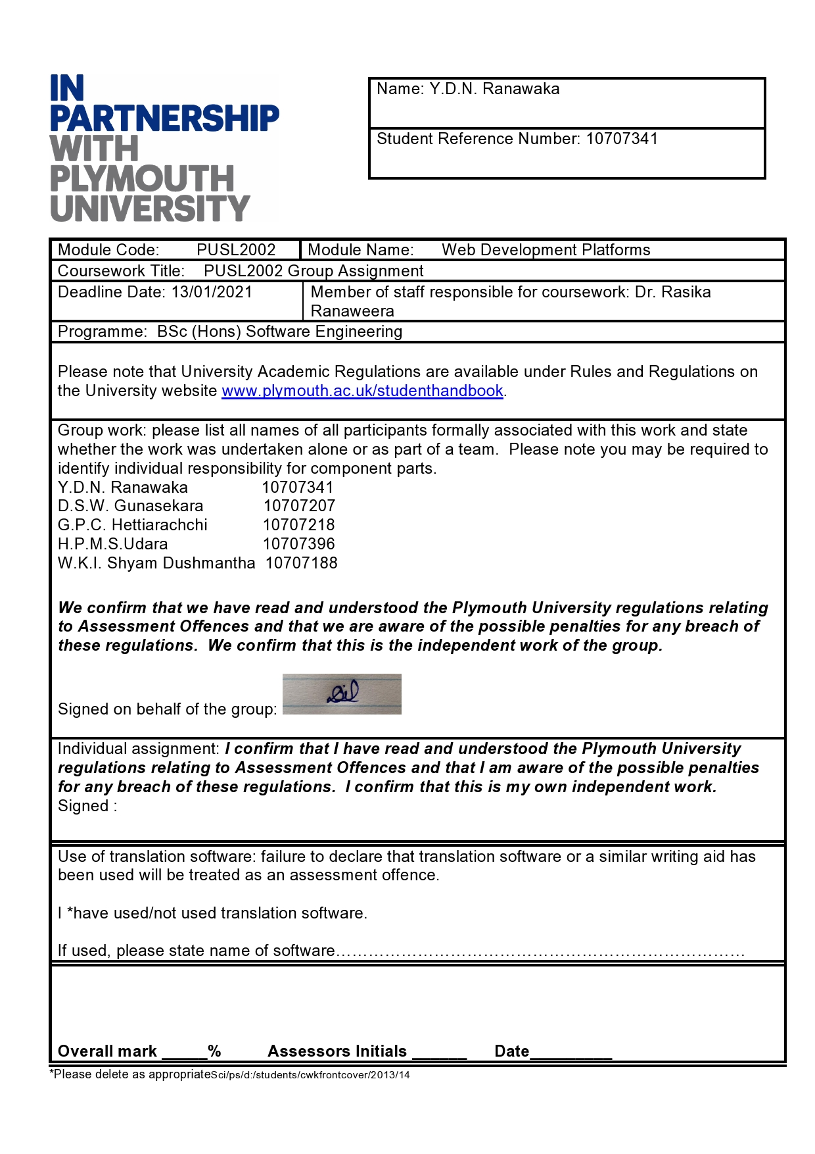

Project Report for the

KEELS ROOTED FOOD MART

DEVELOPED BY TEAM (25)

G.P.C. Hettiarachchi (10707218)

D.S.W. Gunasekera (10707207)

Y.D.N.Ranawaka (10707341)

H.P.M.S.Udara (10707396)

W.K.I. Shyam Dushmantha (10707188)

UNDER THE GUIDANCE OF

Dr. Rasika Ranaweera

Project Submitted for the module

PUSL 2002 Web Development Platforms

Of BSc (Honors) Degree Of

Software Engineering

Plymouth batch 8

19.1/19.2 batch

National School of Business & Management

(Affiliated to the University of Plymouth)

# ACKNOWLEDGEMENT

* We would like to acknowledge our debt to each & every person associated in this Project Development. The Project Development required huge Commitment from all the individuals involved in it.
* We are also thankful to Dr. Rasika Ranaweera who have guided us throughout the Project Development.
* We would also like to acknowledge all the seniors for providing help and solutions for our problems.
* We would like to be grateful for our colleagues for keeping us motivated throughout the time of preparing the Project.
* We would like to be thankful for our parentsin providing us with neccesary materials needed indeveloping the project.
* We are grateful to each & every people involved with us in this case study, without them we wouldn’t have been able to complete the Project within the given Time Frame.

Table of Contents

ACKNOWLEDGEMENT 1

1.0 Introduction 3

1.1 Project Overview 3

1.1.1 Structure of the system 3

1.1.2 Process of the current system 4

1.1.3 Existing system that connects DOA along with keels staff and the farmers 4

1.1.4 SUGGESTED SOLUTION 4

1.2 Proposed System 5

1.2.1 OBJECTIVES OF THE SYSTEM 5

1.2.2 SCOPE OF THE WEBSITE 5

2.0 Theoretical Background 6

2.1 Problem Identification 6

2.2 Functional Requirements 6

2.3 System Design 7

2.3.1 Descriptive Model 7

2.3.2Mathematical Model 7

2.3.3 Graphical Model 7

2.4 Feasibility Study 11

2.4.1 Technical feasibility 11

2.4.2 Economic feasibility 11

2.4.3 Operational feasibility 12

2.4.4 Social feasibility 12

2.5 System Interfaces 13

2.5.1 Samples of the Developed System 13

2.6 System Testing 14

2.6.1 Various Test Methods 14

2.7 Implementation 15

2.7.1 Software Requirement: 15

2.7.2 Hardware Requirement 15

2.8 CHALLENGES faced DURING THE DEVELOPMENT 15

2.9 Scope for further development 16

2.10 Project Schedule 17

2.11 Workload Matrix 18

2.12 Conclusion 19

# 1.0 Introduction

## 1.1 Project Overview

ABOUT SYSTEM

* Project Name – Keels Rooted Food Market

The main aim of this project is toprovide a facility for the keels staff and the farmers to interact with each other. This helps the Department of Agriculture (DOA) of Sri Lanka along with the Keels in launching a web site to develop an online mrket for the farmers. Here, the farmers have the ability of feeding the information of their harvest and Keels staff has the ability of purchasing them through that website.

### 1.1.1 Structure of the system

Keels Rooted Food Market

KEELS STAFF & DOA

Direct messages

Pay,

Communicate,

Reports on their harvest with images

Being paid

View reports, validate

FARMERS

### 1.1.2 Process of the current system

First the farmer has the ability of registering to the system using National ID numbers and the related details of their crops. Then the farmer can report details about the harvest they picked with some supporting images of their harvest. After that the Keels and the DOA staff can view all the details mentioned in th reports, validate them and purchase them if they are in good condition by viewing the photos uploaded. Keels staff can communicate with the the relevant farmers using direct messages and can send requests to the farmers by viewing the map after evaluating the qaulity of the harvest.

### 1.1.3 Existing system that connects DOA along with keels staff and the farmers

The existing system of Keels is a manual one.Here, Here mostly File processing systems were used in the recording process of the information about farmers and the harvest supplied by them.The present system used in recording information about farmers and their harvest is very time consuming andcostly, as it requires a huge heap of paperwork and those activities took place by the farmers by visiting Keels and the DOA staff.

### 1.1.4 SUGGESTED SOLUTION

Solution is to make a website where the farmers can feed their harvest and the keels staff can view, vlaidate and buy them.The reasons for making a website where farmers and the keels can interact onlineare listed as follows :

* Increasing the efficiency by reducing the cost.
* Reducing the huge load of paper works.
* Saving time in recording details of farmers and their harvest.
* For the easy generation of the required reports.

## 1.2 Proposed System

### 1.2.1 OBJECTIVES OF THE SYSTEM

* The main objective is todevelop and design an efficient system that is user friendly.
* Computerized systemfor easy use as all the stuff are done online through the website.
* Developing an accurate, flexible systemin reducing data duplicacy and redundancy.
* Saving both time and money.
* Providing better user friendlyand attractive user interface.
* Privacy as well as security aspects are ensured about the details about the supermarket as well as the farmers that send harvest to the supermarket using this online platform.

### 1.2.2 SCOPE OF THE WEBSITE

* Storage of information of the farmers, their main crops and the harvest details.
* Validating theinformation supplied by the farmers about the harvest by viewing images of harvest.
* Storage of information about the farmers using National Id numbers.
* Generation ofrequiredreports about the farmers, the harvest they received and the ones that are wasted.
* Building up communication between farmers and the Keels/DOA staff.

# 2.0 Theoretical Background

## 2.1 Problem Identification

Problem Identification is one of the most important activities during the development of this project regarding the preparation of a website. Here, defining the problem and designining a solution related to that problem are the main parts of this problem identification. Developing a website with low risks and more efficient can be done by getting a clear idea about the problems associated with the exixting system used by the Keels staff. This step also describes about the readily available sources that should be associated with the website.

## 2.2 Functional Requirements

* There should be an “Web Master” who can create accounts for the Keels and DoA staff.
* Farmers can sign up for free. Registered farmers can input data (including images), delete and update his/her own reports.
* Keels and DoA staff can see the reports as a list and on a map, click to reveal more details on a popup dialog box (similar interface like Figure 1).
* Keels staff can then buy or ignore the products and set a flag based on the quality of product such as red flag for terrible (inedible).
* DoA staff can see the graphs; analysis of types of products, locations most farmers reside, successful transactions, and wasted products.
* Keels staff can see the product reports. Different flagged reports are displayed with different icons on a map. More information can be seen when such an icon is clicked.
* General public can see the farmers’ reports on a map but without the details of farmer. The public is also eligible for view of graphs.

This is the process that defines the architecture, the modules, the interfaces, and data that is needed by the system to satisfy different requirements.

## 2.3 System Design

### 2.3.1 Descriptive Model

* Structured English or Pseudo codes
* Event list
* Process Description
* Decision Tree
* Decision Table

### Mathematical Model

### 2.3.3 Graphical Model

* System Flow Chart
* Data Flow Diagram (DFD)
* Entity Relationship (ER) Diagram
* Class Diagram
* Use Case Diagram

Some grpahical models used in developing of the Rooted Food Mart Website.

#### ER Diagram

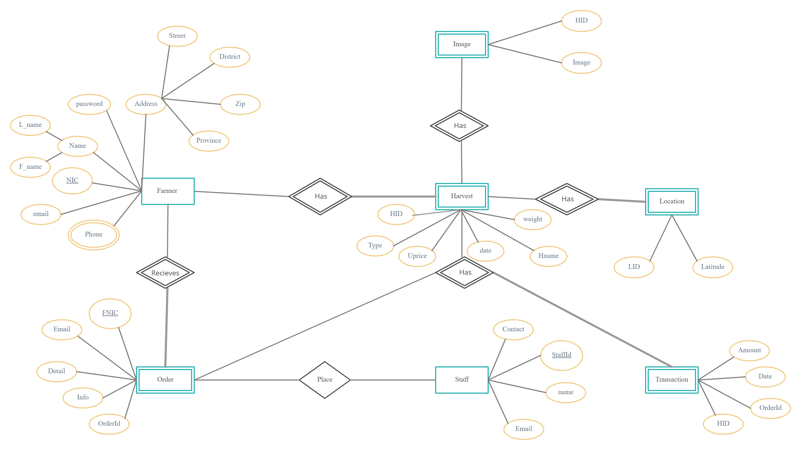

#### Class Diagram

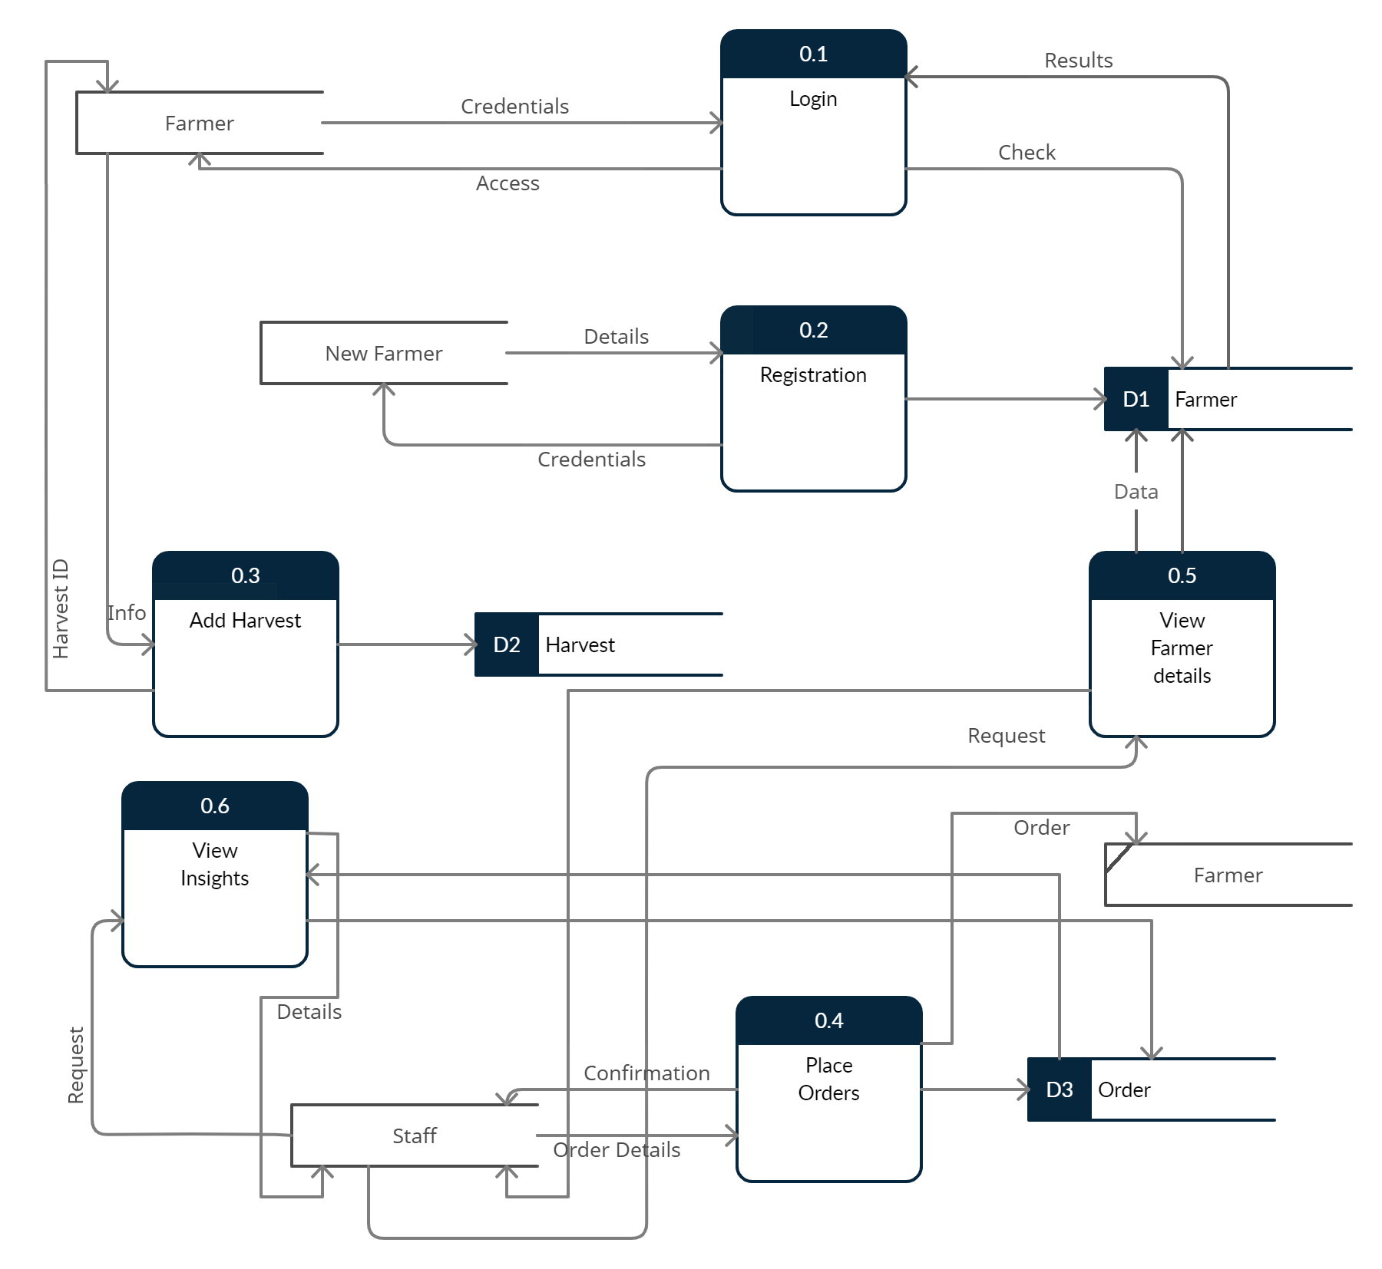

#### Use Case Diagram

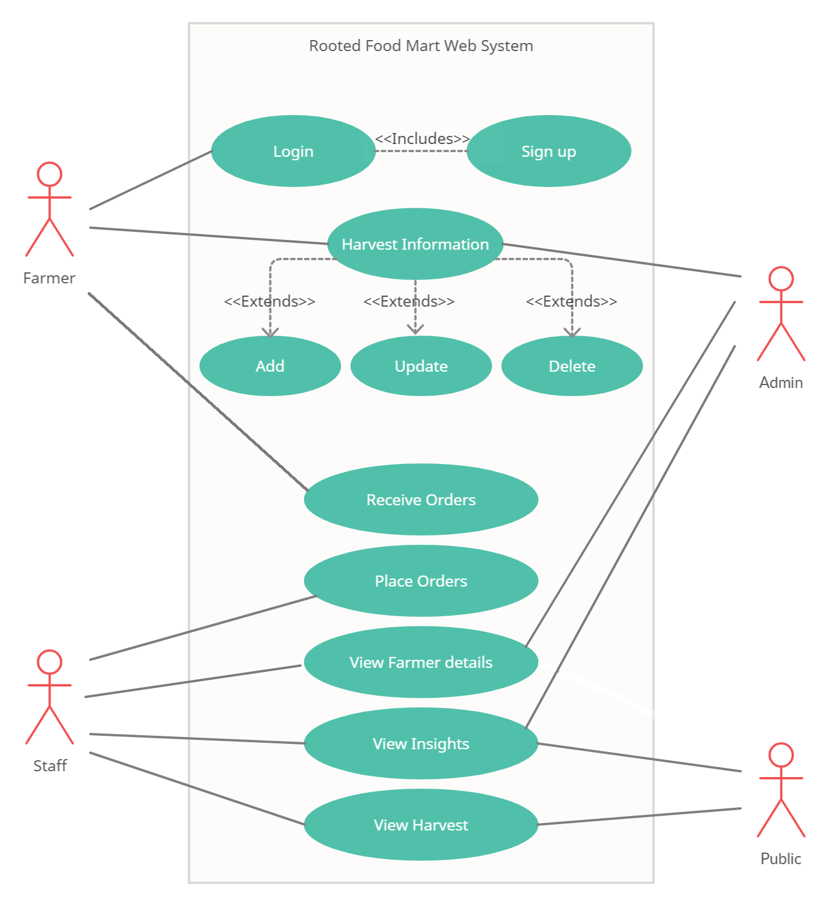

# **2.4 Feasibility Study**

The main aim of Feasibility Study is providing theoritical solutions for the problems that resulted in developing the project. The objective of evaluating feasibility is to check the capability of developing and implementing a system with the internal/external resources available with us. This determines the inputs and outputs of the system. following points are considered uunder confirming the project feasibility.

Feasibility study of theRooted Food Mart was taken place as follows:

### 2.4.1 Technical feasibility

Thisanalyseswhether the proposedsystem that connects the farmers and the keels staff together is technically feasible and whether we have required tools,methodologies, technical knowledge and personals to make this project a success.Simply this gives us an idea whether we can build that project regarding the web site.

Following criteria are considered regarding Technical Feasibility,

* Familiarity with the technology and application
* Size and the complexity of the website
* Compatibility of the website

### 2.4.2 Economic feasibility

The analyses whether this proposedsystem is economically feasible.That is identifying whether the project gives us financial benefits and costs. Economic feasibilty shows whether we can get a profit than the initial cost we invested in developing the website.

Following criteria are considered regarding Economic Feasibility,

* Costs in developing
* Annual operating costs
* Annual benefits with relation to the costs spent on developing and operating
* Benefits that are intangible

### 2.4.3 Operational feasibility

This analyses whether the proposed system is operationally feasible. This feasibilty study checks whether it solves the targetted problems or takes advantages of the opportunities. Project is worth developing if that can achieve the required tasks.

This is done by getting ideas by the system users. Operational Feasibilty helps in identifyingwhether the proposed solution satisfies above organization needs or not. Operational Feasibilty determines whether the newly propsed computerized system is extremely user friendly when compared with the existing manual system.

### 2.4.4 Social feasibility

Social Feasibilty is responsible in facilitating the user to perform operations like generating error free reports. So, there is no any possiblereason of making the system that is not socially feasible.

# 2.5 System Interfaces

## 2.5.1 Samples of the Developed System

## A home page is the main web page of a website, it is also known as the start page. Above figure shows the home page of “ROOTED FOOD MART” web-based system. This interface contains mart, harvest, place order, insights, services, sign in and sign up options.

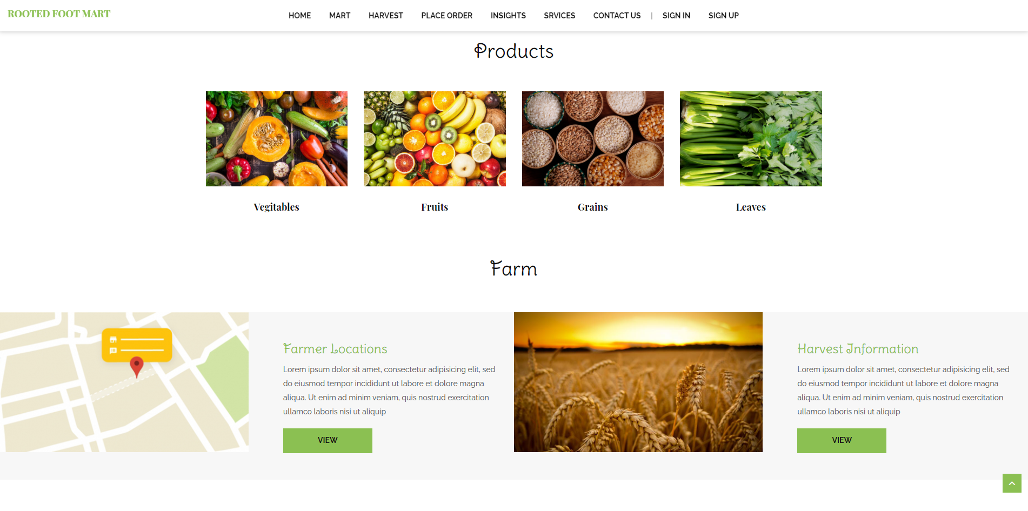Home Page

Harvest Information Add

This Page is to add harvest information namely Harvest ID, NIC no, Email of the farmer, Name of the farmer, Date of the harvest, Type of the harvest and etc.

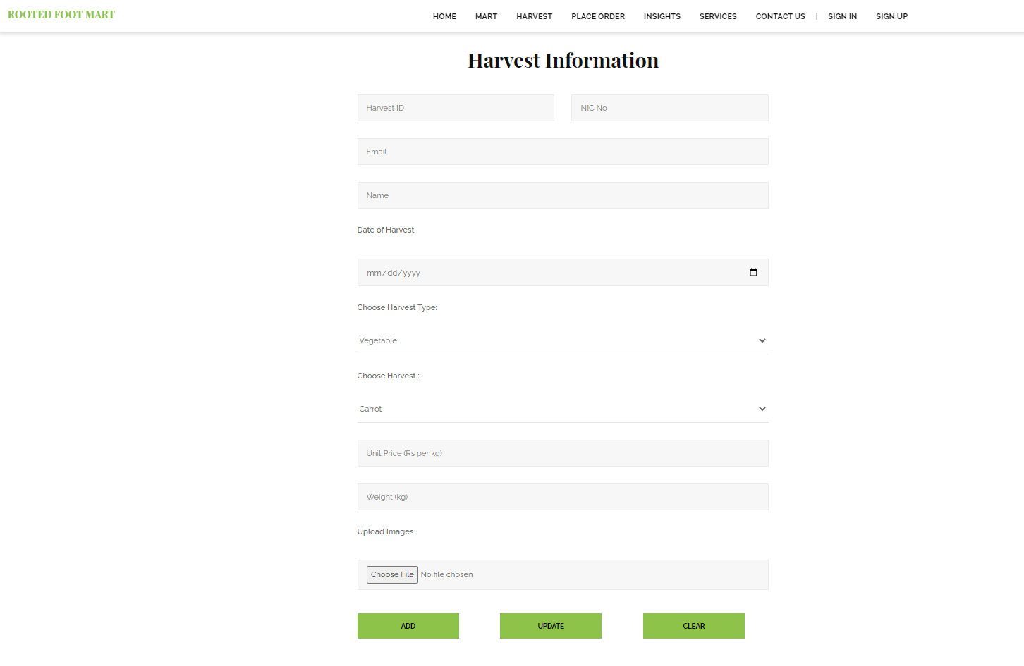

Direct Message and Giving the Order to the farmer

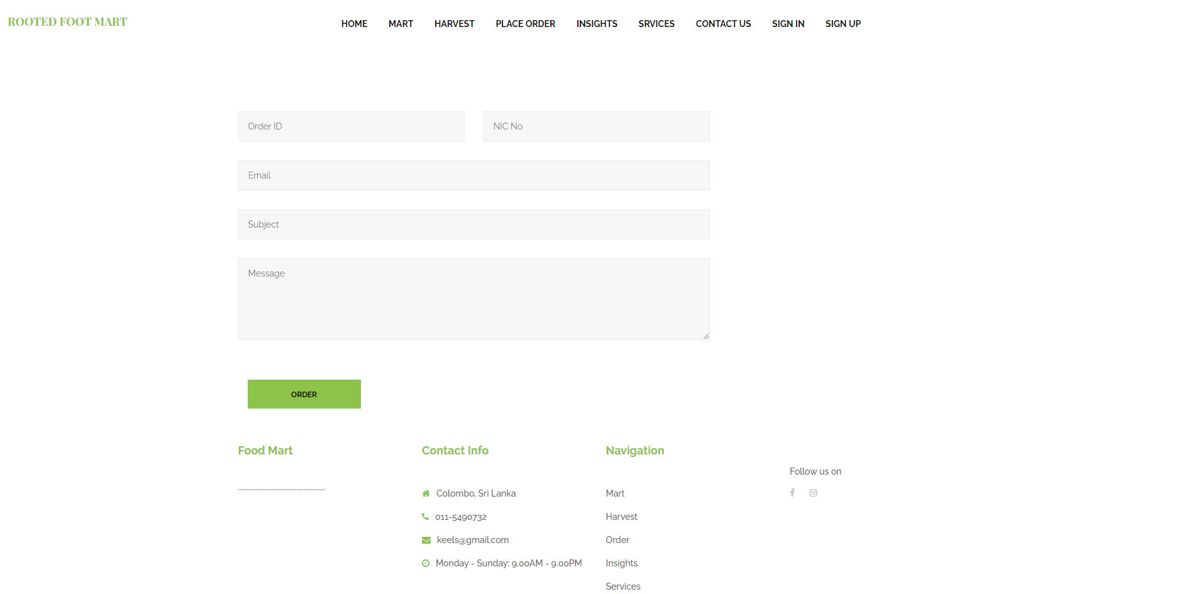

This web page is used by the DOA along with the KEELS staff to give an order to a farmer and this page gives the opportunity to the staff to direct message with the Farmers.

Sign In

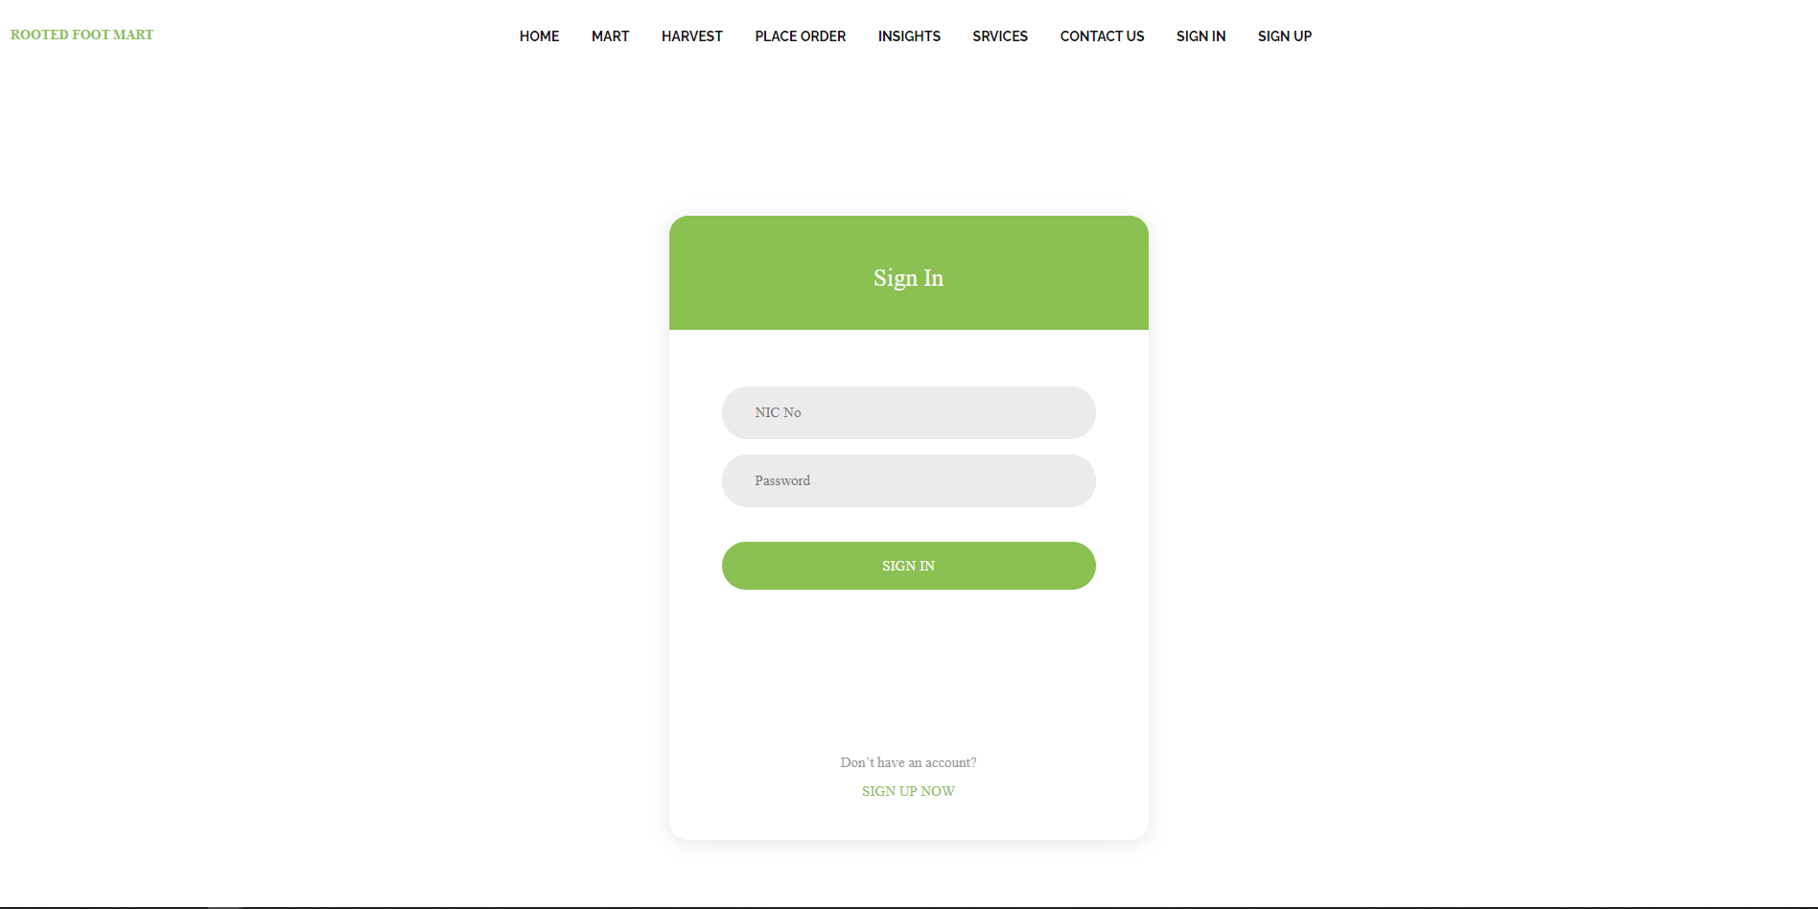

This allows the farmers to sign in to the web site who have already signed in earlier.

Sign Up

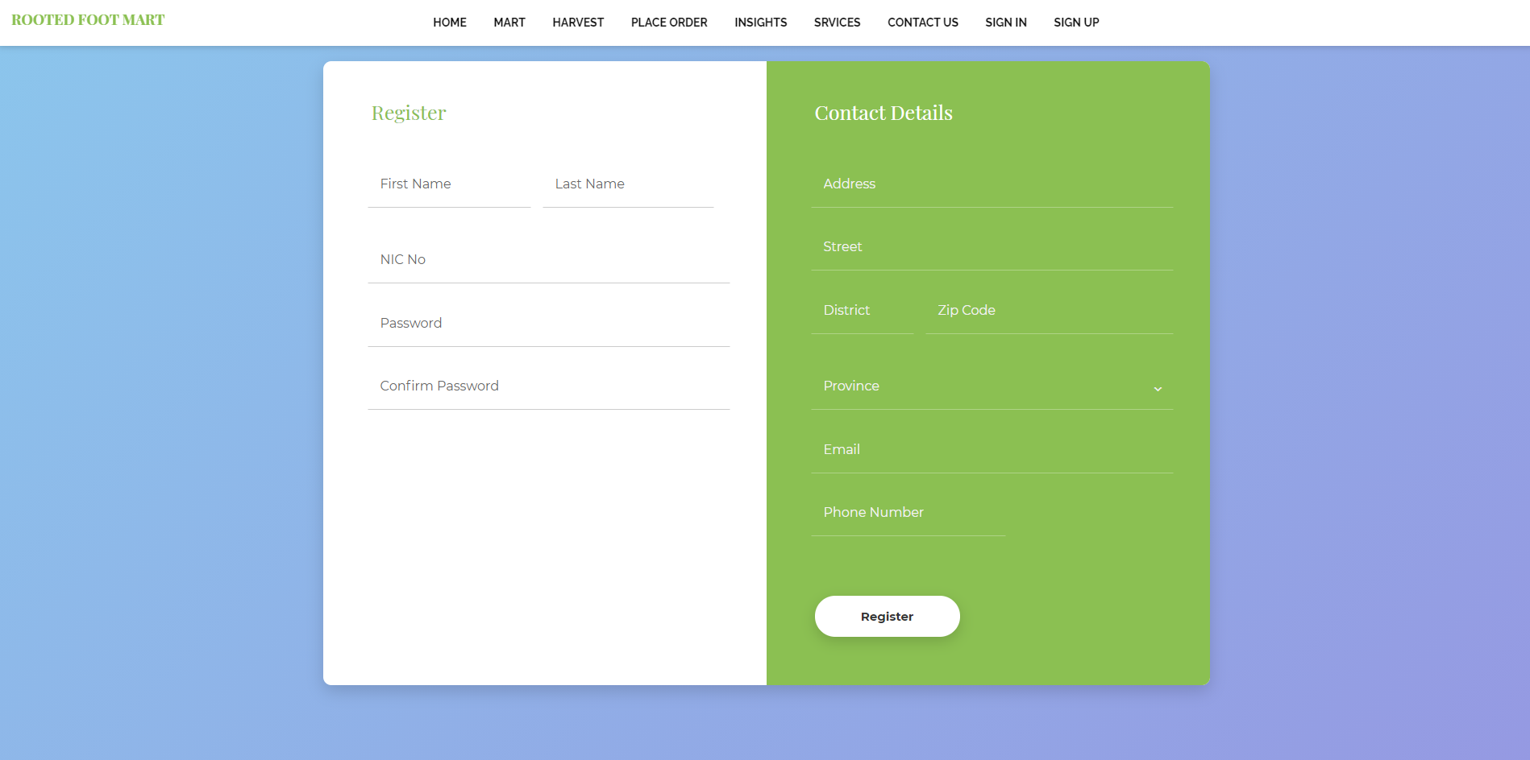

This allows the farmers to register in this website by adding his contact details, NIC number, address, Province, district and etc.

Graphs that show information about the harvest that they gained and the wasted harvest

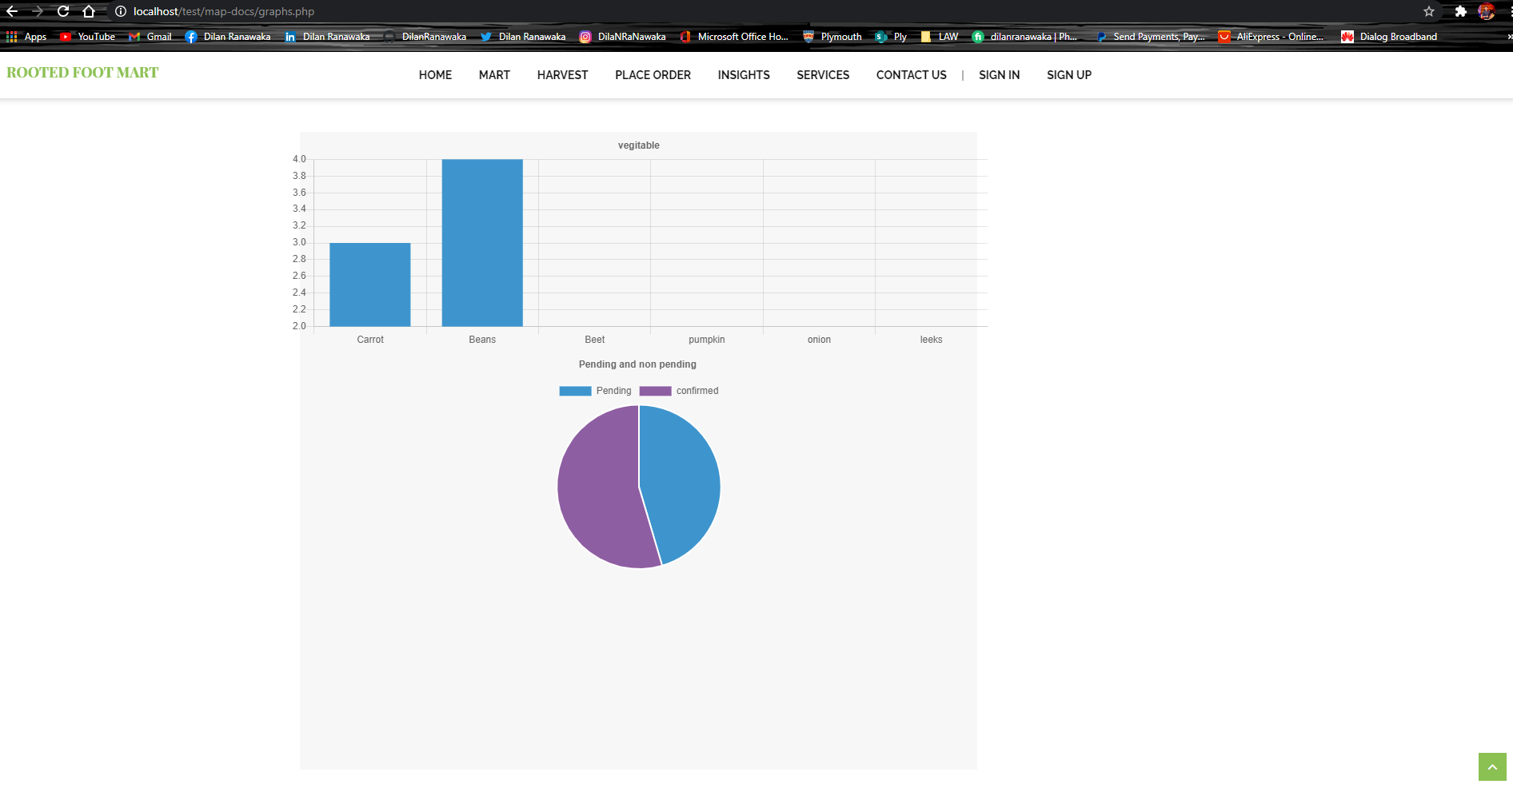

These graphs are used to demonstrate percentages of fruits, vegetables, successful transactions and wasted harvest.

Map that shows the Location of the farmers

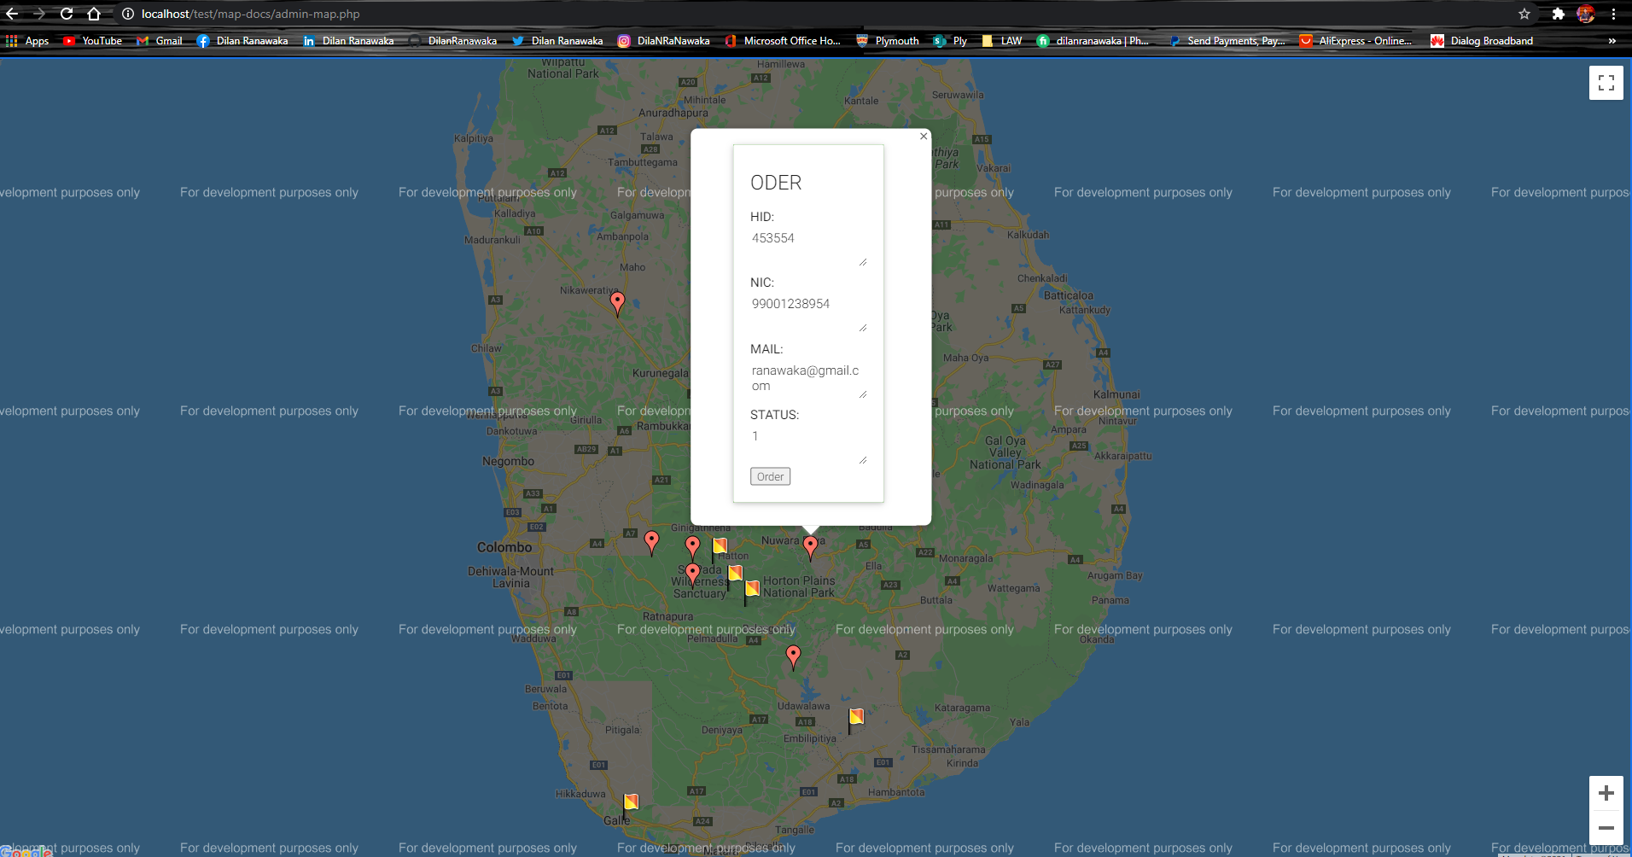

This shows the locations of the farmers with their particular details such as email and etc.

# 2.6 System Testing

Critically test and review the website including functionality testing, Acceptance testing, compatibility testing, functionality and error detecting.

## 2.6.1 Various Test Methods

1. Functionality testing

* check whether all the links, and buttons are working
* all validations in form fields are working properly
* there must be no any dead page or invalid outputs

2) Usability testing

* It is to be checked navigation across the website is proper, check whether we can reach home/index page from any of the web pages
* Check whether the website is easy to use and interact
* Font size, font color and images across the website are easy and convenient to use
* The content within the web site must attract and appeal the users of this web site.

3) Compatibility test

* check whether the application can be run across multiple browsers
* it must be operable on various devices like mobile phones, notebooks, and computers

# 2.7 Implementation

System implementation is the most important steps in case of finalizing the approved web system. We need to justify some basic requirement (software & hardware) so that the system will work without having obligation and customers dissatisfactions.

## 2.7.1 Software Requirement:

• Operating System: Windows (XP, 7, 8, 8.1) or Mac OSX (Tiger, Leopard, Snow Leopard, Lion, Yosemite).

• Web Browser: Google Chrome, Internet Explorer (ver. 8 or later), Mozilla Firefox, Safari (Mac).

• Database Management System: MySQL, SQL Server, Microsoft Access, Oracle.

• Web Development System: Visual Studio 2010 or later, Adobe Dreamweaver, Notepad, and Notepad++.

• Others: .NET FRAMEWORK.

## 2.7.2 Hardware Requirement

• RAM: Minimum 1GB or higher.

• HDD: Minimum 50 GB.

• Processor: Intel Pentium 4 or AMD.

• LAN: Version 1.6.6.406(For fixing up client disconnection)

# 2.8 Challenges Faced during the development

* Problems occurred during the process of entering the locations of farmers as they are not aware about the longitudes and latitudes.
* Farmers do not have enough technical knowledge.
* Challenges in marking the locations of those farmers in maps.

# 2.9 Scope for further development

This is a user friendly and an attractive website that is developed in a way that can accept further modifications and in a way that any changes can be applied in the future.

Every system should allow scope for further development or enhancement. The system can be adapted for any further development. This website is so flexible to allow any modification need for the further functioning of programs.

Since the objectives may be brought broad in future, web pages can be easily modified accordingly, as it has been modularized. The future expansion can be done in a concise manner in order to improve the efficiently of the website.

# 2.10 Project Schedule

|  |  |  |  |  |
| --- | --- | --- | --- | --- |
| NO | PHASES | STARTDATE | DURATION  (DAYS) | FINISHDATE |
| 1 | PROJECT SEARCH& FINALIZE | 15/12/2020 | 3 | 17/12/2020 |
| 2 | GATHER INFORMATION | 18/12/2020 | 2 | 19/12/2020 |
| 3 | REQUIREMENT OF PROJECT | 20/12/2020 | 3 | 22/12/2020 |
| 4 | SCHEDULLING THE PROJECT | 23/12/2020 | 1 | 24/12/2020 |
| 5 | CREATE GITHUB REPOSITORY | 25/12/2020 | 3 | 27/12/2020 |
| 6 | DATA & PROGRAM MODELS& DIAGRAMS | 28/12/2020 | 3 | 30/12/2020 |
| 7 | FRONT END DEVELOPMENT (HTML, CSS, JAVASCRIPT) | 31/12/2020 | 4 | 03/01/2020 |
| 9 | BACK END DEVELOPMENT (PHP CODING) | 04/01/2020 | 4 | 07/01/2020 |
| 11 | TESTINGS AND CONNECTIONS | 08/01/2020 | 3 | 10/01/2021 |
| 12 | COMPLETE REPORT | 11/01/2021 | 2 | 13/12/2021 |

# 2.11 Workload Matrix

|  |  |
| --- | --- |
| Team Member | Contribution |
| Y.D.N.Ranawaka (10707341) | Front end Development |
| G.P.C. Hettiarachchi (10707218) | Databases and Forms Backend |
| D.S.W. Gunasekera (10707207) | System Analysis and Report |
| H.P.M.S.Udara (10707396) | Maps |
| W.K.I. Shyam Dushmantha (10707188) | Diagrams |

# 2.12 Conclusion

The Website of the Rooted Food Mart that gives the ability to the farmers and the Keels staff along with the DOA to interact is successfully developed by fulfilling all the requirements identified during the process of system analysis. This system was designed very much user friendly and in an efficient manner.

The newly produced website is much reliable, user friendly when compared with the existing system and this has been developed, designed and tested step by step successfully. It eliminates the human errors that can be occurred during collection of data or even in calculations. This website makes the system more effective and organized.

Data and information are not needed to record and store manually as all the functions are done using the computerized system so, the cost is minimized in case of stationary.

-THE END-